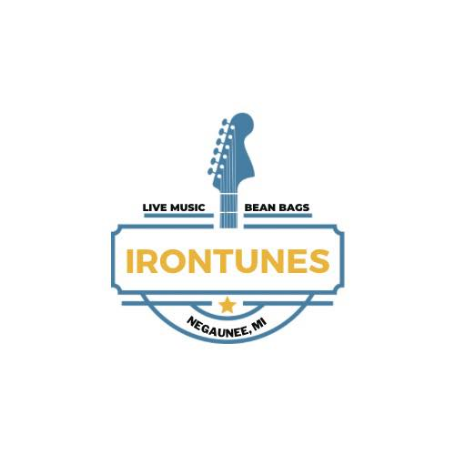

Irontunes 2024 Grant Application
Please fill out this application to be considered for a $100.00 grant to have live music played on site of your business. Please refer to the eligibility requirements to determine if you can apply. Please note, you must fill out a separate application if you are requesting more than one grant. Please see web page for further details www.negauneedda.com.
ELIGIBILITY REQUIREMENTS
- Must own a business or property in TIF District #1 or #2. Must be a business not a home or residence.
- Musician must perform live music, not a DJ.
- Musician must perform one of the dates shown below. No other dates are eligible.
- Musician must perform for a period of at least 2-hours, between 6pm and 10pm.
- Grant award is only valid with signed grant agreement.
- Grantee must provide proof of service (receipt) in order to receive reimbursement.
- Grantee must provide completed W9 with application.
- Grantee must post on social media and on internal posters that a musician will be performing.
- Application must be returned in person only at the Utility Billing Window.

Business Name: _____________________________ Contact Number: _______________

DATE REQUESTED FOR GRANT BAND INFORMATION
- July 18th August 8th Band Name: _________________________
- July 25th August 15th
- August 1st Performance timeframe: _______________

DATE RECEIVED

Approved (Internal Use Only)

