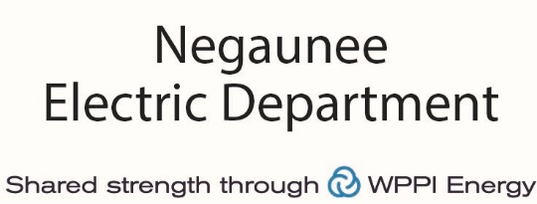

2022 Negaunee Electric Department Community Grant Application

Negaunee Electric Department and WPPI Energy provide grants local organizations to encourage energy conservation and awareness within the community.

Available Grants
Community Contributions Grants: $500 - $1,500

Program Grant Qualifications:
Community Contributions Grants are used to support local projects and programs sponsored by community organizations such as school programs, local non-profits, Irontown Association, etc.

Program Grant Instructions:
- Complete the information below. Describe how the project or program qualifies as defined above and how the funds will be used. Be sure to indicate the amount requested (up to $1,500). Individual grant amounts will be based on how many grant requests are received.

- Grant requests are due to the Negaunee City Treasurer by May 20, 2022.
Name of Organization: _________________________________________________________
Contact Name: _______________________________________________________ ________
Phone Number: __________________ Email Address: __ ________________________
Mailing Address: __________________________________ _______________________
Program Grant: Community Contributions Grant Amount Requested:_____________________
Provide a brief description of the project/program and how it benefits the citizens of Negaunee: _____________________________________________________________________________
_____________________________________________________________________________
_____________________________________________________________________________
______________________________________________________________________________
______________________________________________________________________________
______________________________________________________________________________
______________________________________________________________________________
______________________________________________________________________________

*Upon acceptance of the funds the group must make themselves available for press materials*

