City of Negaunee
PO Box 70
319 W. Case Street
Negaunee, MI 49866
March 19, 2024
SURPLUS EQUIPMENT BID
BOSS V-PLOW
Sealed bids for Boss V-Plow will be received by the City of Negaunee. Bids accepted until 9:30am ET on April 10, 2024.

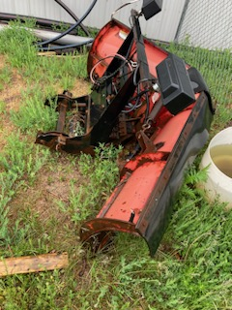
City of Negaunee
Attn: Judy Iwanski
P.O. Box 70
319 W. Case Street
Negaunee, MI, 49866

Individuals are welcome to stop to view the surplus equipment located at the DPW Office, 600 Cherry Street in Negaunee. Monday through Friday, 6:30am to 2:45pm.
Individuals please clearly mark “BID ENCLOSED – Boss V-Plow” on the outside envelope of sealed bid.
The Individuals Name, Address, Phone Number shall also be clearly marked on the bid.
Failure to make payment for the item within 3 days of the Bid Opening will result in bid rejection, and the City will select the next highest bidder.
All bids must be Mailed or Hand-Delivered; email or fax bids will be not be accepted.
The Bid Form is enclosed.
CITY OF NEGAUNEE

BID FORM

Individual: _______________________________

Address: _______________________________

_______________________________

Phone Number: _______________________________
Email Address: _______________________________

City of Negaunee
SURPLUS EQUIPMENT BID
Item Description | Quantity | Unit | BID Price (Minimum BID = $50)
Boss V-Plow AS-IS CONDITION | 1 | EACH

NOTE: Failure to make payment to the City of Negaunee for the item within 3 days of the Bid Opening will result in bid rejection, and the City will select the next highest bidder.

